BREBEUF COLLEGE SCHOOL
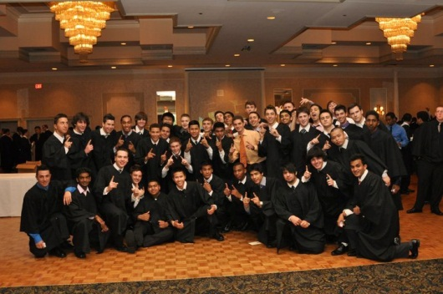
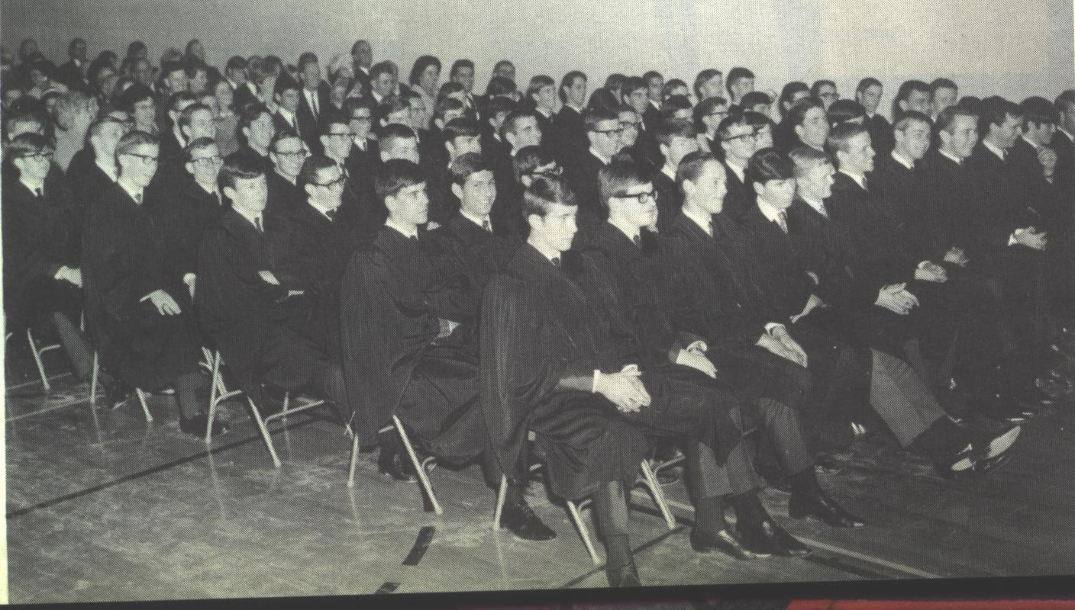
GRADUATION 2023

BREBEUF GRADUATION 2023

STAFF CONTACTS: Mr. M. Da Costa michael.dacosta@tcdsb.org
Mr. T. Tanchez (principal) james.tanchez@tcdsb.org

Dear Graduates and Parents:

Enclosed you will find important information on the Graduation Ceremony and other activities for the Class of 2023. Please ensure your son joins the Guidance Google Classroom as updates will be posted there periodically – ldt22gu. In order to make the graduation from Brebeuf a meaningful and memorable occasion for you and your families, we wish to draw your attention to the following items.

GRADUATION FEE:

The cost for a student to attend Graduation is $120.

Payment should preferably be made online via School Cash Online. A link for the payment will be emailed to all parents of graduates. The deadline is Friday, May 19.

Notes:

- If for any reason a student does not meet the requirements for Graduation or cannot attend, all fees will be refunded.
- If there are any financial issues, please contact Mr. Tanchez or Mr. Da Costa.

The Graduation Fee covers the following:

- Graduation hall rental
- Graduation invitations and programmes
- Graduation decorations
- Graduation prizes and awards
- Honorarium for Mass Celebrant & Guest Speaker
- Diploma cover
- Professional Photographer
- Graduation gown
- Mass programme
- Graduation Breakfast
- Tickets for four guests per student

Important Dates:

Wednesday, June 28, 2023

GRADUATION MASS, BREAKFAST & REHEARSAL (for students and staff)

Note: Parents are welcome to attend the Graduation Mass portion of the morning.

Graduation Mass and Breakfast: STUDENT ATTENDANCE IS EXPECTED

- 9:00 a.m. in the Gym
- Please dress in business casual clothing and neat attire (no hats, t-shirts, shorts, or running shoes).
- The Breakfast will take place in the Atrium immediately following Mass. There will also be some special presentations and entertainment, and some awards will be distributed.

Graduation Rehearsal: ATTENDANCE IS MANDATORY

- 12:00 p.m. immediately following the Graduation Breakfast in the Gym
- You must be ON TIME. If you are late, you will hold up the entire rehearsal.
- A student who misses the rehearsal may not be eligible to participate in the Graduation Ceremony or receive invitations or a gown.
- Distribution of graduation invitations will take place after the rehearsal (4 per student). Depending on the graduating class size, a small number of additional invitations will be sold for $5 after the rehearsal.
- Distribution of gowns will follow the rehearsal. Students must have a gown for the Ceremony.
- Only the GRADUATE can pick up his gown and invitations.

Thursday, June 29, 2023

GRADUATION CEREMONY

DA VINCI BANQUET HALL
5732 Hwy 7 #33, Woodbridge, ON L4L 3A2

- Graduates to assemble at the Da Vinci Banquet Hall by 9:00 a.m. SHARP.
- Ceremony will begin at 10:00 a.m. SHARP.
- Parents, family members and graduates will not be permitted into the banquet hall before 9:00 a.m.
- Students must bring their GRADUATION GOWN with them and be dressed in semiformal/formal attire (dress shirt, tie, dress pants, dark dress shoes).
- All staff, graduates and guests must leave the banquet hall by 1:00 p.m.
- Guests MUST have their tickets available to enter the hall.
- Give yourself plenty of time to get to the banquet hall!

GRADUATION PHOTOGRAPHS:

As in the past at Graduation, family members are welcome to take pictures before and after the ceremony. However, during the actual presentation of diplomas PARENTS ARE NOT PERMITTED TO TAKE PICTURES at the presentation stage, as this interferes with the professional photographs and obstructs the view of other guests. Order forms for photos will be included in the envelope the student receives after the Graduation Ceremony.

All outstanding obligations, i.e. monies, sports or music equipment, library materials, etc, must be resolved prior to June 17, 2023.

We will make every effort to make your graduation a special day for you and your family. It does, however require much planning, organization and complete cooperation. Please assist by observing the timelines outlined above.

GRADUATION CRITERIA:

A student will be eligible for graduation if he has earned his OSSD at Brebeuf College School. It is the student’s responsibility to ensure that all diploma requirements have been fulfilled (including community service hours). If any student wishes to clarify his status, please consult the Guidance Department.

BREBEUF GRADUATION AWARDS

Please go to www.brebeufalumni.org/awards for important information regarding being considered for awards and applying for specific graduation awards. Students are encouraged to send in their resumes. As well, some awards require separate applications. Below is a list of our awards. All monetary values are subject to change.

AP = annual plaque/trophy kept at school
PP = personal plaque given to student
$ = monetary award (some awards might be divided between multiple winners in which case the money is split)

* Academic Awards are given for the highest mark in each Gr. 12 subject. [PP]

* Blessed Edmund Rice Society medals are given to all students who were named to the Honour Roll in all four years at Brebeuf.

* The Medal of the Governor-General of Canada is awarded to the student with the highest average in both Grades 11 and 12. [medal from GG,PP,AP]

* The Father Winston Rye, S.J. Award is given to the student with the highest average in Grade 12. [$200,PP,AP]

* Ontario Scholars had an average of over eighty per cent on their top six Grade 12 courses regardless of when and where they were taken. [certificate]

* The Honour Roll recognizes students who had an overall average of at least eighty per cent in their Grade 12 year at Brebeuf. [certificate and pin]

* The Lieutenant Governor's Medal is given to a student with an exemplary record in performing community service. [Pin from LG]

* The E.J.Barry Renaissance Award is presented to a student who displays an interest and active participation in all aspects of student life: academics, sports, the arts, and social activities. This award is offered in celebration of the contribution of Mr. E.J. Barry (staff 1963-1996) to the Brebeuf community. [AP, PP, $500 from George Macri]

* The O'Neil Gazeley Scholarship is awarded to a student who, in his years at Brebeuf, has demonstrated a commitment to his peers and dedication to academic excellence. This award is in recognition of Mr. Neil Gazeley who was Brebeuf's first Vice-Principal and a tremendous leader in the Catholic community. [AP,PP,$500 from George Macri]

* The Brebeuf Benefactors' Award is presented to an individual who has contributed his talents to the betterment of Brebeuf College School. [AP,PP, $200]

* The Presentation Brothers' Award is presented to a student who has demonstrated personal and academic growth and development in his years at Brebeuf. [PP,AP, $250 from Brothers]

* The Brother Lawrence Maher F.P.M. Award, named after our former Principal, is presented to the student who has shown a commitment to spirituality within the school community, has embraced many aspects of school life, has shown a willingness to help other students, and who has given an indication that he will pursue further education. [AP,PP,$200 from CSPC]

* The Michael Brown Memorial Award is dedicated to a former Brebeuf student. This award is presented to a student who best exemplifies school loyalty and generous co-operation. [AP,PP,$200]

* The Joe Will Award is presented to a student who has made a significant contribution to the quality of school life and whose character and accomplishments exemplify the mission of the school. [AP,PP,$200]

* The Man for Others Award is presented to a student who exemplifies the school’s mission of forming “men for others” [PP,AP, $200].

* Catholic Student Award is presented to a student who has embodied the school’s Catholic mission. [$200,PP]

* The St. Clair Monaghan S.J. Scholarship Award goes to the student who displays high academic achievement, strong athletic and/or extra-curricular involvement, and expresses a firm commitment to become involved in Alumni affairs. [$250 from Alumni,PP,AP] (Requires separate application )
* The Visual Arts Award is presented to a student who has demonstrated outstanding ability and commitment to the field of Visual Art. This award is dedicated to the memory of Mark Agcaoili ‘92. [PP]

* The Theatre Brebeuf Award is presented to the graduating student who has greatly contributed to the theatre programme over his years at Brebeuf. [PP]

* The Lou Puccini Scholarship, named for a former teacher, is given to the graduating student who has been diligent, persevered in his studies, and overcome various challenges. This award is generously funded by George Macri. [$500,PP,AP]

* The Michael Tomaszek ’82 Music Award in sponsored by the Alumni Association and recognizes a graduating student who has contributed significantly to the music programme. [$250 from Alumni,PP,AP]

* The Michael Thompson ’69 Award is a new award named in honour of Michael Thompson, Class of 1969, an Honour Student, and Athlete of the Year. It is given to the graduating student who best combines academics, athletics, and good sportsmanship. This award is generously funded by the Thompson Family. [$250,PP,AP]

* The Gerry Tanner Award is named for the mother of Brett Tanner '81. This award helps to assist with university finances and it recognizes a graduating student who has contributed to school life at Brebeuf .[$2000 from G. Tanner,PP].

* Toronto Secondary Unit (OECTA) Award is given to a student for demonstrating social and political responsibility by participating in school or community activities that promote social justice and foster Catholic values. [$100 from OECTA, certificate]

* The Peter Knopfel ’81 Memorial Scholarship is dedicated to the memory of Peter Knopfel, a 1981 graduate. The Alumni Association and the Knopfel family award this scholarship to the graduate who has demonstrated academic and social achievement through his strong sense of commitment. (requires separate application) [$5000 from Knopfels,PP,AP]

* The Michael Daoust ’67 Mathematics Award is awarded to a graduating student for overall excellence in mathematics. It is named for Michael Daoust, a Brebeuf alumnus, teacher, department head, and mentor from 1967 to 2010.[PP,AP]
The Martin Foy ’82 Scholarship is named in memory of Martin Foy, Class of 1982. It is awarded to a graduating student in the Specialist High Skills Major Programme in Information and Communication Technology. Similar to Martin, the recipient has demonstrated outstanding effort, determination, perseverance, and integrity in completing the course expectations in the specialist programme and has been accepted to a post-secondary institute. This is generously funded by the Foy family and friends of Martin. [$1000,PP,AP]

The Father James Webb, S.J. Award is named for a former Brebeuf teacher and Jesuit Provincial. It is given to a graduating student who has shown a commitment to social justice. [PP,AP]

The Marcus McInerney Scholarship is a new award generously funded by Barry McInerney, Class of 1981, and Rose McInerney in memory of their son and is presented to a deserving graduating student to assist with post-secondary education.

The Catholic Women’s League Scholarship is a new award sponsored by the C.W.L. at Blessed Trinity Parish. It is for a graduating student who is entering an apprenticeship programme and celebrates determination and commitment to succeed while making a positive contribution to his high school community.

Raphael Kum Ming Loh ’03 Award for Most Improvement honours a former Brebeuf student and teacher. He was a true “Man for Others”. This award, which is generously sponsored by the Loh family, is presented to the graduating student who has made the most academic improvement between Grades 9 & 12.

Raphael Kum Ming Loh ’03 Award for Sports Leadership is also an award to honour Raphael Loh and funded by the Loh family. It is for a graduating student who has shown tremendous leadership in athletics.

Valedictorian and Salutatorian Guidelines

Below is a brief explanation of what is involved in being either the Valedictorian or the Salutatorian for the June 29, 2023 Graduation Ceremony. Students who feel they would be able to speak well at a public function such as this are encouraged to apply for these positions.

VALEDICTORIAN: A Valedictory address is a farewell address (5-10 minutes in length) in which appreciation and gratitude are expressed. The various aims of this address are to inspire the graduates and to thank individuals responsible for their successes while reflecting on the accomplishments of the class. The valedictory address should include:

- Introduction
- Advantages of a Catholic Education and Environment – intellectually, spiritually, physically, etc..
- Reminiscences or flashbacks (some tasteful humour) of Brebeuf College School, gratitude to parents, teachers, administration and fellow students.
- Future challenge to Graduates
SALUTATORIAN: A salutatory address is a welcome greeting (1-2 minutes in length). The salutatory address should include:
1. Introduction
2. Welcome and appreciation to the guests for coming
3. Brief reference to Brebeuf College School Conclusion
Requirements for both Candidates:
General Requirements:
- Ability to be creative in composing a valedictory address or a salutatory address
- Ability to present the address clearly, maturely, meaningfully and with conviction
- Ability to present to a group with very different outlooks and opinions by being a capable spokesperson.
- Student must write a brief written response (Please see following page)
- Student requires: 3 Teacher References and 5 Peer References
Academic Requirements:
- Student must currently have 75% or above average from courses taken at Brebeuf.
- Student should have no history of disciplinary history (subject to principal’s discretion).
Extra-Curricular Requirements:
- Student should have been actively committed to extra-curricular activities during his four years at Brebeuf College.

Important Dates to Remember:
Submit your completed form for only ONE of the above positions to Mr. Da Costa in Room 213 or the main office by May 12, 2023.
NOTE: Valedictorian and Salutatorian speeches MUST be handed in to Mr. Da Costa at least 2 weeks prior to the Graduation Ceremony. You will be required to practise your speech in front of some teachers prior to the ceremony.

VALEDICTORIAN OR SALUTATORIAN APPLICATION

Name of Nominee:

I wish to run for (circle one) VALEDICTORIAN OR SALUATORIAN

Teacher References:
Teacher Name | Teacher Signature

Peer References:
Peer Name | Peer Signature

Written Component:
Please write a brief response to the following question: How have you modelled yourself as a man for others while at Brebeuf College School?

